**Tic Tac Toe**

**A Mini Project**

**Academic Year: 2021 - 22 EVEN SEMESTER**

**Department with Specialization : B.Tech., – Computer Science and**

**Engineering with Specialization in Big Data Analytics**

**Semester : II**

**Course Code : 18CSS101J**

**Course Title : Programming and Problem**

**Solving**

*Submitted by*

ISHIKA JAGATRAMKA [RA2111027010212]

*Under the Guidance of*

Dr. S Sarvanan



DEPARTMENT OF NETWORKING AND COMMUNICATIONS

COLLEGE OF ENGINEERING AND TECHNOLOGY

SRM INSTITUTE OF SCIENCE AND TECHNOLOGY

KATTANKULATHUR- 603 203

FEBRUARY 2022

**Abstract of our project---**

The tic tac toe game is played on a 3x3 grid the game is played by two players, who take turns.  The First player marks the cross, the second player marks a circle. The player who has formed a horizontal, vertical, diagonal sequence of three marks first wins.

Project Algorithm

1. START
2. DECLARING an array name Square­­
3. DECLARING new function checkwin, drawboard
4. CALLING drawboard function inside the main function
5. DECLARING variable
6. USING do-while loop
7. USING if-else condition inside the loop
8. CALLING checkwin function inside the main function
9. USING if-else condition for checking the game won by which player or the game draws
10. USING if-else condition inside the checkwin Function for winning condition the game
11. USING PRINTF statement inside the drawboard Function for making the format of Tie Tac Toe Table
12. END

Project Flowchart

­

False

TRUE

GAME DRAW

**TRUE**

False

**END**

Print invalid syntax

PRINT GAME DRAW

**PLAY AGAIN**

PRINT WHICH PLAYER WINS

CHECK WINNING CONDITION BY

CHECKWIN()

Let players play their chances simultaneously

Player 1 is (x) and player 2 is (o)

START

Source Code

#include <stdio.h>

#include <conio.h>

#include <windows.h>

#include <stdlib.h>

char square[10] = {'o','1','2','3','4','5','6','7','8','9'};

int checkWin();

void drawBoard();

int main(){

system("color 4f");

int player = 1, i, choice;

char mark; // X,O

do{

drawBoard();

player = (player % 2) ? 1 : 2;

printf("Player %d enter the choice : ",player);

scanf("%d",&choice);

mark = (player == 1) ? 'X' : 'O';

if(choice == 1 && square[1] == '1')

square[1] = mark;

else if(choice == 2 && square[2] == '2')

square[2] = mark;

else if(choice == 3 && square[3] == '3')

square[3] = mark;

else if(choice == 4 && square[4] == '4')

square[4] = mark;

else if(choice == 5 && square[5] == '5')

square[5] = mark;

else if(choice == 6 && square[6] == '6')

square[6] = mark;

else if(choice == 7 && square[7] == '7')

square[7] = mark;

else if(choice == 8 && square[8] == '8')

square[8] = mark;

else if(choice == 9 && square[9] == '9')

square[9] = mark;

else {

printf("Invalid Input");

player--;

getch();

}

i = checkWin();

player++;

}while(i == -1);

drawBoard();

if(i==1){

printf("==>Player %d Won",--player);

}

else {

printf("==>Game draw");

}

getch();

return 0;

}

int checkWin(){

if(square[1] == square[2] && square[2] == square[3])

return 1;

else if (square[4] == square[5] && square[5] == square[6])

return 1;

else if (square[7] == square[8] && square[8] == square[9])

return 1;

else if (square[1] == square[4] && square[4] == square[7])

return 1;

else if (square[2] == square[5] && square[5] == square[8])

return 1;

else if (square[3] == square[6] && square[6] == square[9])

return 1;

else if (square[1] == square[5] && square[5] == square[9])

return 1;

else if (square[3] == square[5] && square[5] == square[7])

return 1;

else if(square[1] != '1' && square[2] != '2' && square[3] != '3' && square[4] != '4' && square[5] != '5' && square[6] != '6' && square[7] != '7' && square[8] != '8' && square[9] != '9')

return 0;

else

return -1;

}

void drawBoard(){

system("cls");

printf("\n\n\t Tic Tac Toe \n\n");

printf("Player1 (X) - player2 (O) \n\n\n");

printf(" | | \n");

printf(" %c | %c | %c \n",square[1],square[2],square[3]);

printf("_____|_____|_____\n");

printf(" | | \n");

printf(" %c | %c | %c \n",square[4],square[5],square[6]);

printf("_____|_____|_____\n");

printf(" | | \n");

printf(" %c | %c | %c \n",square[7],square[8],square[9]);

printf(" | | \n");

}

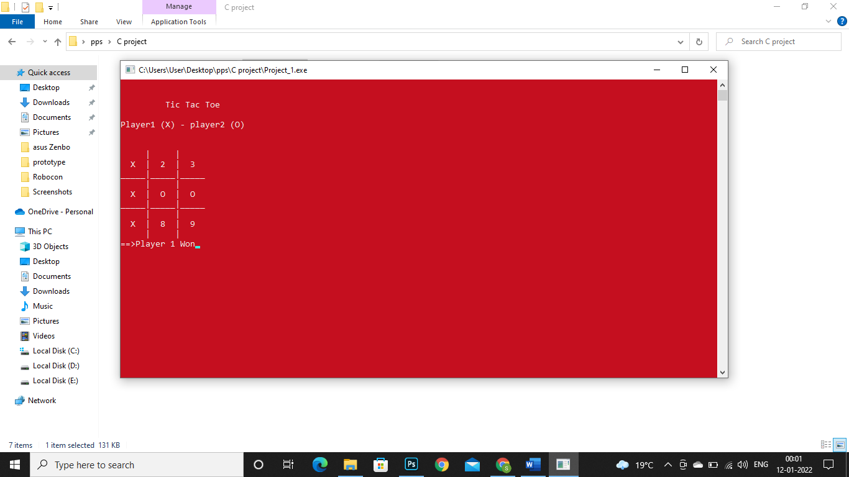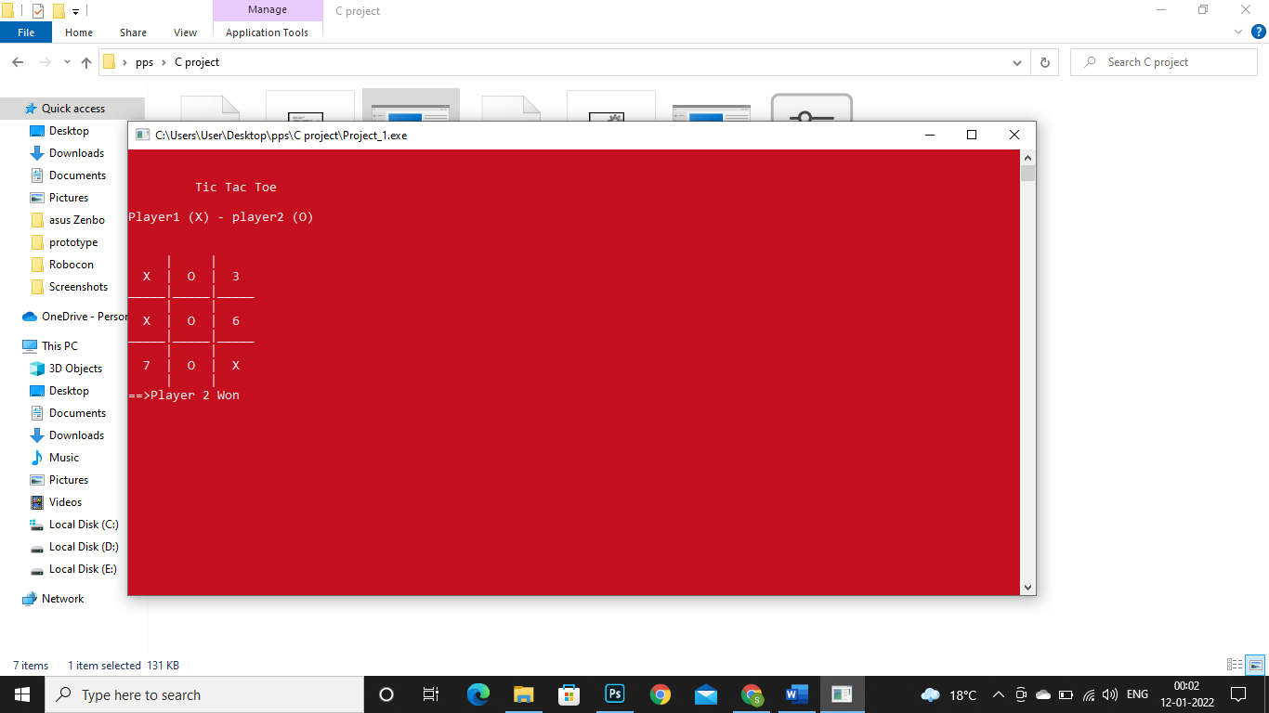

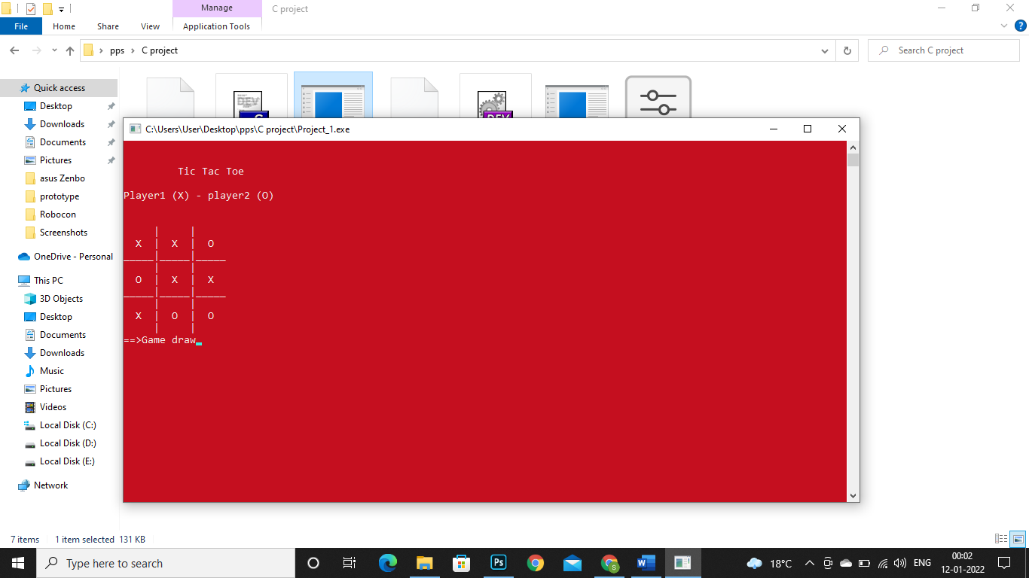

**Result ---**

This game concludes if all the three contiguous boxes or diagonal boxes of the same symbol are filled with either “X” or “O”.If the before mention condition is not satisfied and all boxes are filled with symbols of the game then the game will be declared drawn.

**Conclusion ---**

This game is very exciting as in this game all three results i.e. (win, lose or draw) are possible and the best thing about this game is !! a tic tac toe game takes only 30 seconds to complete. You can play many tic tac toe games in a very short span of time.

This game will remind you of those days of childhood when we use to play tic tac toe on sand or on the back of the notebook with our friends. This game will help you to release your stress.